**KVM Install**

**Step2:**

**Step 3:**

step 6:check if virtualization is enabled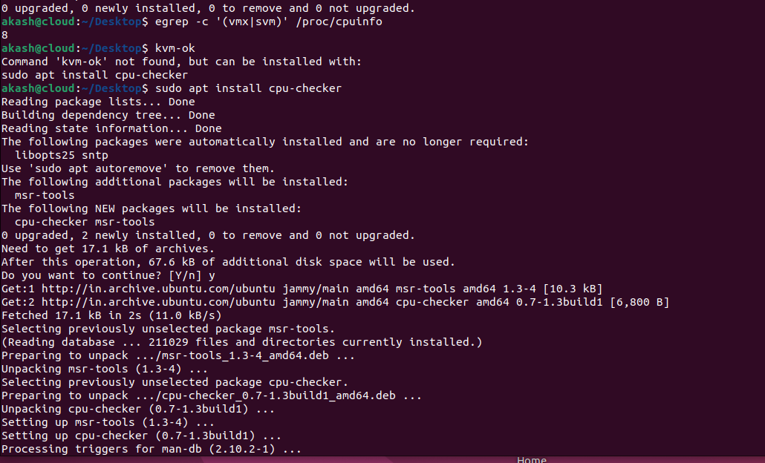step 7:**

**Step8:**

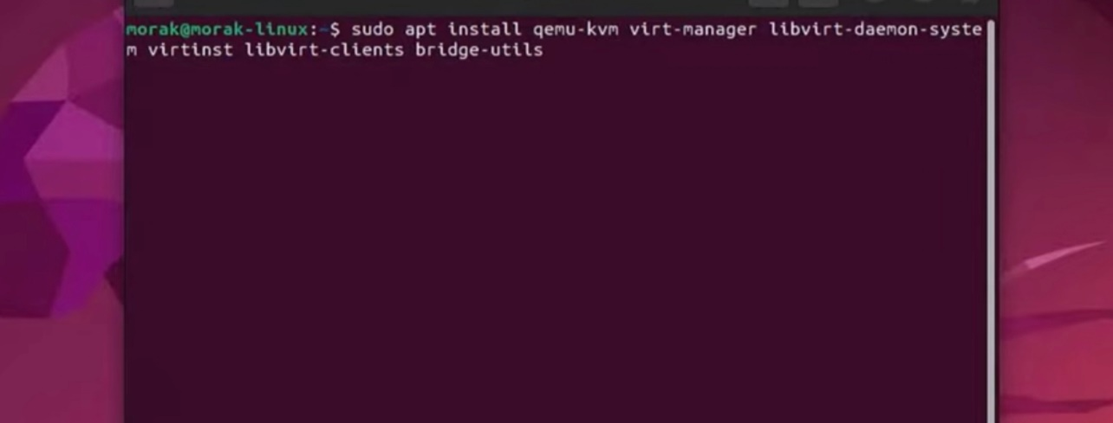

**Step 10:**



